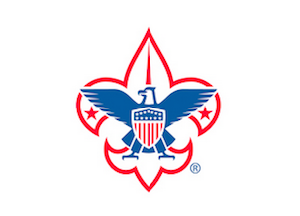
BLACK FEATHER DISTRICT
EARTH DAY CLEAN-UP SERVICE PROJECT
CHATFIELD STATE PARK
SATURDAY APRIL 23RD

SCOUT PARKING PASS

